1. Create an API Key and Secret in Octane. Assign the key to access the workspace you want to generate the report. Tool requires Space admin access in order to retrieve users’ information at the shared space level.

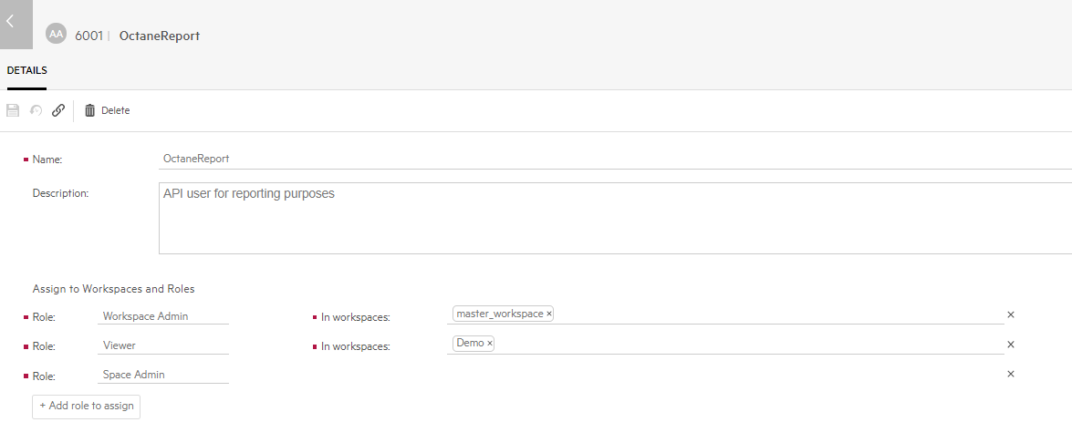

1. Bring up the Excel macro.
2. Enter the Octane server information

Example:

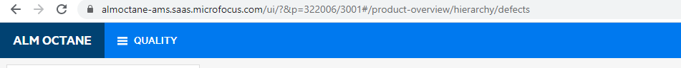

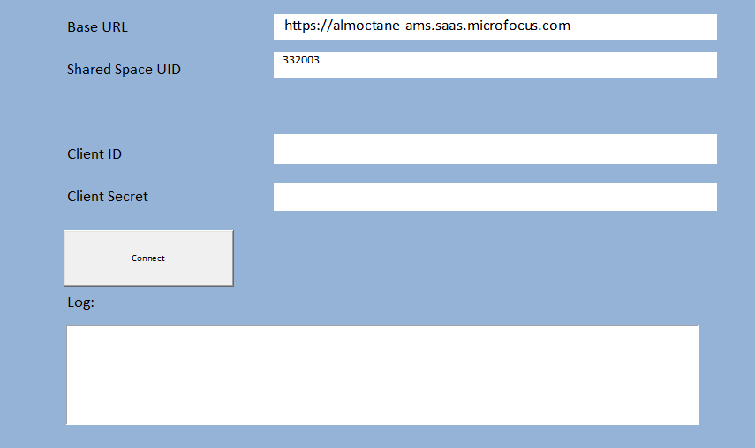

1. Click on “Connect” button to generate the report.
2. Navigate to the “Users List” tab to review the report.

